*Florida International University*

*School of Computing and Information Sciences*

CIS 4911 - Senior Capstone Project

Software Engineering Focus

Feature Document

User Story # 596

**Team Member:**

Garrett Lemieux

**Product Owner(s)**:

Francisco Ortega

**Mentor(s)**:

Francisco Ortega

**Instructor**: Masoud Sadjadi

**User Story – implement feedback for leap motion**

* As a User I would like feedback when I switch draw settings using the Leap Motion device and interact with UI so I know intended actions with Leap Motion were successful.
* Acceptance Criteria:
  + Provide feedback in the form of an image.
  + Gesture must change current Ui or draw settings.

**Use Case: User Performs Leap Motion Hand Gestures**

User wants to change the shape setting, color setting or save the current canvas by using leap gestures.

* Details:
* Actor:
  + User
* Pre-conditions:
  + TouchPoint app is running.
  + Leap motion and multi touch devices are connected.
* Description:
  + Use case begins when User has decided to change the shape setting, color setting, or wants to save the current canvas using leap motion gestures.
  + User performs a swipe gesture when he or she wants to change current drawing color.
  + User performs a swipe circle gesture when he or she wants to change current shape being drawn.
  + User performs a keyboard tap gesture when he or she wants to save current canvas.
  + Use case ends once the user finishes performing a gesture.
* Post-conditions:
  + The shape or color has changed or the canvas has been saved depending on the gesture used with the leap motion.
* Alternative Courses of Action:
  + User can perform a swipe vertically or horizontally to change color to be drawn.
  + User can do a clockwise or counterclockwise circle gesture to change the shape to be drawn.
* Decision Support:
  + Frequency: High , User will need to vary his or her shapes and colors used to when drawing and he or she will need to save the canvas they are working on.
  + Criticality: High , Allows Users to draw different designs by changing shapes and colors using leap gestures. Also will be able to save a canvas without the need of multi touch device.
  + Risk: Medium, Had gesture recognition implemented but needed to integrate the shape and color change functions to work for both multi touch and leap motion devices.
* Usability:
  + Difficult, Need to learn how to perform leap gestures correctly.
* Reliability
  + High
* Performance
  + Performance: High
  + Failure: Low, once user knows how to perform gesture
* Supportability
  + Leap Motion Device
* Modification History:
  + Owner: Garrett Lemieux
  + Initiation Date 2/21/2016
  + Date last Modified: 5/2/2016

**Use Case Diagrams**

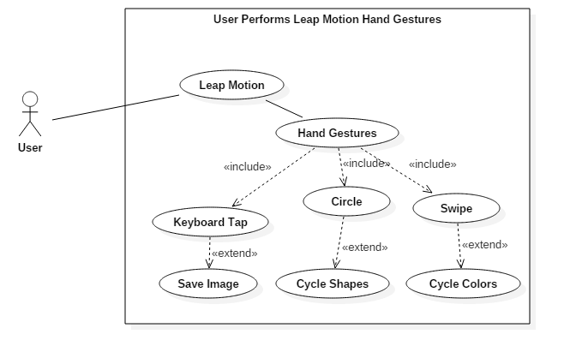

**Sequence Diagrams**

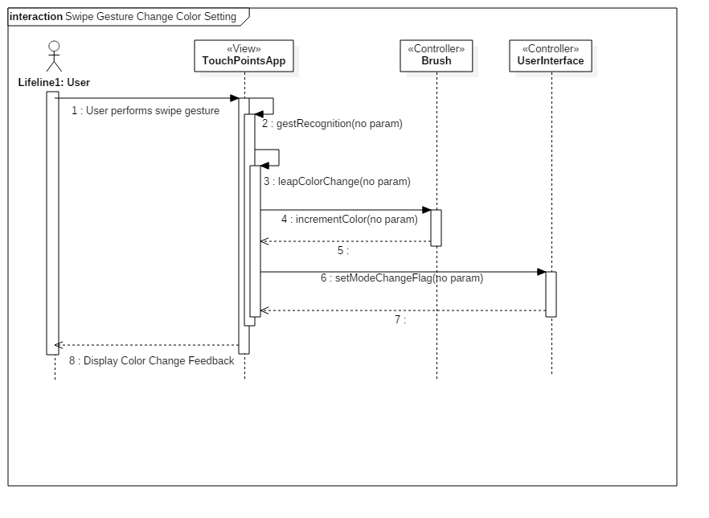

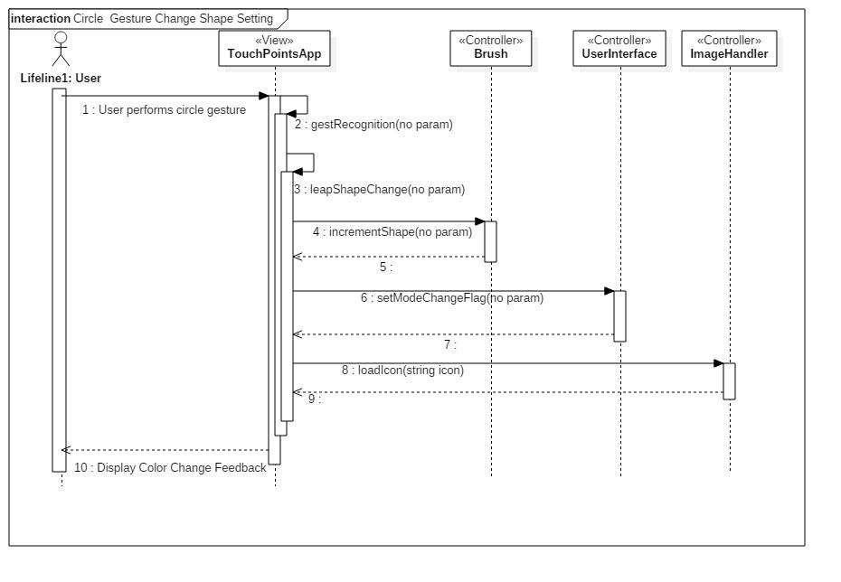

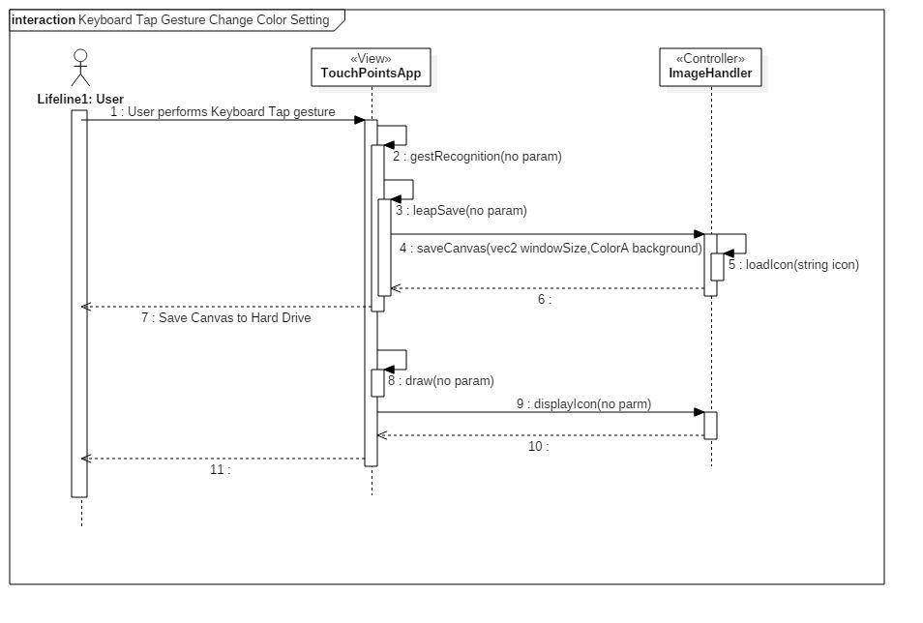

**Class Diagram**

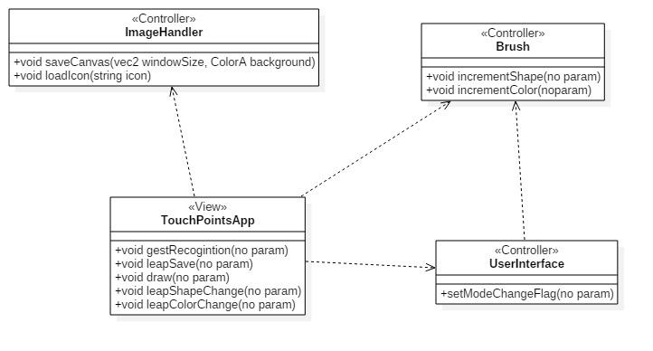

**Unit Test**

* Sunny Day Test:
  + Test Case  - User wants to Change the Color setting
    - Test Purpose: Test if swipe gesture changes the color draw setting.
    - Test Procedure: User starts application. Then user does swipe gesture both vertically and horizontally. Observes the results.
    - Expected Results: User should see feedback in the form of a box with the new color setting for drawing. Since the user performed swipe gesture twice he or she should experience this result two times.
  + Test Case  - User wants to Change the Shape setting
    - Test Purpose: Test if circle gesture changes the color draw setting.
    - Test Procedure: User starts application. Then user does circle gesture both clockwise and counterclockwise. Observes the results.
    - Expected Results: User should see feedback in the form of a box with the new color setting for drawing. Since the user performed circle gesture twice he or she should experience this result two times.
  + Test Case  - User wants to Save Canvas
    - Test Purpose: Test if keyboard tap gesture saves the current canvas.
    - Test Procedure: User starts application. Then user draws on canvas and performs a keyboard gesture. Observes the results.
    - Expected Results: User should see feedback in the form of a save icon and user should be able to retrieve saved image.

.

* Rainy Day Test:
  + Test Case  - User Performs incorrect Circle Gesture
    - Test Purpose: Test if user performs circle gesture incorrectly expected results occur.
    - Test Procedure: User starts application. Then user rotates finger in semi-circle instead of 360 degrees.
    - Expected Results: User should not see feedback in the form of a box with the new shape setting for drawing. Since the user did not perform a complete circle gesture. If shape changes test failed.
  + Test Case  - User Performs incorrect Swipe Gesture
    - Test Purpose: Test if user performs swipe gesture incorrectly expected results occur.
    - Test Procedure: User starts application. Then moves hand from left to right every half second. User does the same in the vertical direction.
    - Expected Results: User should not see feedback in the form of a box with the new color setting for drawing. Since the user did not perform a complete swipe gesture. If color changes test failed.

**Integration Testing**

* The ability to use change of shape and color  functions works in TouchPointsApp.cpp
  + When swipe and circle gesture are recognized by leap motion.
  + Both devices now are set to same shape and color and either device can be used to draw the current shape and color.
  + When keyboard tap gesture is recognized canvas drawn by either device is saved.
* Both devices can work at same time and any change done by either device makes changes occur to both devices when drawing.

**User Guide**

* Once a user has decided to change the current shape that will be drawn by either device he or she must perform a circle gesture.
  + In order to perform a circle gesture user's hand must be in the field of the leap motion. He or she starts to draw a circle in either clockwise or counterclockwise direction.
  + The gesture is made by holding hand and wrist steady and using your index finger. Once a full circle has been created the gesture will be recognized.
  + A successfully read gesture will perform an the desired action and a picture will appear providing feedback to the user.
  + The feedback image will slowly fade out.
  + No other gesture may be read during that time.
  + Expected Feedback can be seen Below:

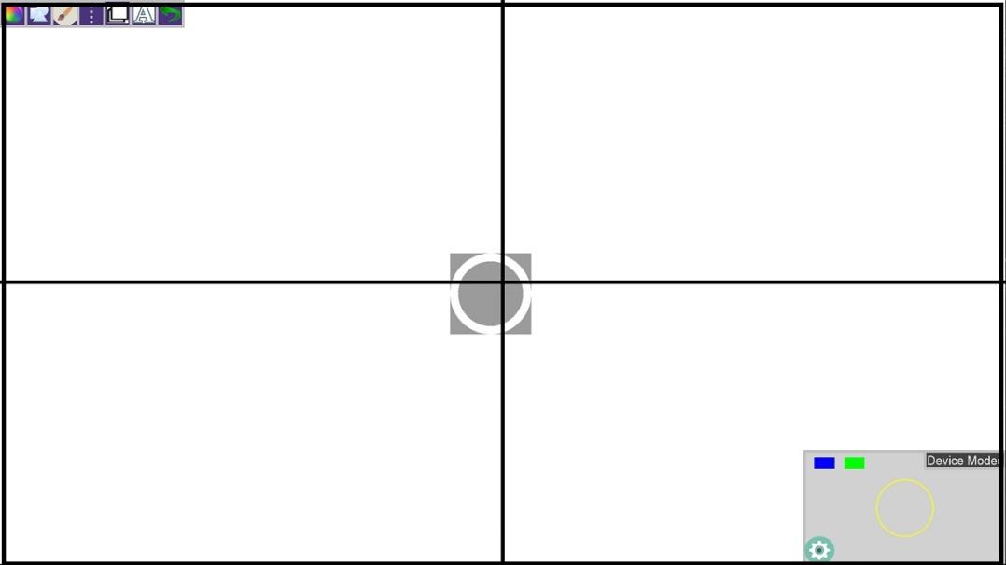

* Once a user has decided to change the current color that will be drawn by either device he or she must perform a swipe gesture.
  + In order to perform a swipe gesture user's hand must be in the field of the leap motion. He or she starts to perform a swipe by starting at either the left or right side of leap motion.
  + The gesture is made by holding hand and wrist steady and using your index to demonstrate a swipe by moving arm from left to right or right to left depending on starting position of hand.  Once a full swipe has been created the gesture will be recognized.
  + The swipe gesture can be made in the vertical direction as well following the same direction but in the y axis instead of the x axis.
  + A successfully read gesture will perform an the desired action and a picture will appear providing feedback to the user.
  + The feedback image will slowly fade out.
  + No other gesture may be read during that time.
  + Expected Feedback can be seen Below:

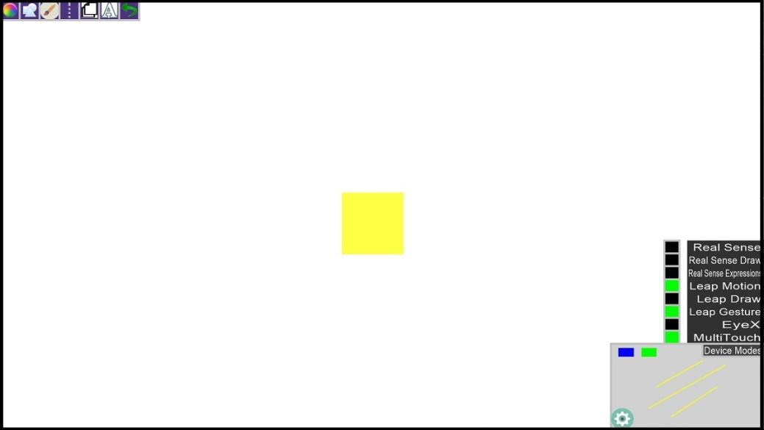

* Once a user has decided to save his or her canvas a keyboard tap gesture must be done.
  + In order to perform a keyboard tap gesture user's hand must be in the field of the leap motion. He or she starts to perform by holding hand and wrist steady and using your index to simulate the pressing of a keyboard.
  + A quick movement downward with finger will perform a keyboard tap gesture.
  + A successfully read gesture will perform an the desired action and a picture will appear providing feedback to the user.
  + The feedback image will slowly fade out.
  + No other gesture may be read during that time.
  + Expected Feedback can be seen below:

